**Trainer Notes:**

**Note: Once the student completes the ONTAPADM labs please inform support to reset the PODs to DATAPROT images, since in our environment we use two different images for ONTAPADM and DATAPROT classes.**

Do not continue with DATAPROT class on same ONTAPADM image which may results in storage outage. This will lead to shut down the images in all the PODs, which will need to reset the PODs to initial state to access the images back.

**Module 0: Welcome**

**Exercise 1: Checking the Exercise Equipment**

**Note:** In our lab environment we use AD and Jumphost as a same server and the IP is set to **192.168.0.253**. So, use **DNS, NTP and Gateway** as **192.168.0.253** throughout the lab.

**Task 2: Configure PuTTY Saved Session**

**Page13_Step2-7:** After changing the Font click **OK**.

**Task 3: Verify that Required License Codes Are Installed**

**Page15_Step3-1:** The screenshot may vary with the license installed so kindly refer the below image. Since the **Volume encryption license works only in hardware and the working is subjected to the region it is deployed.**

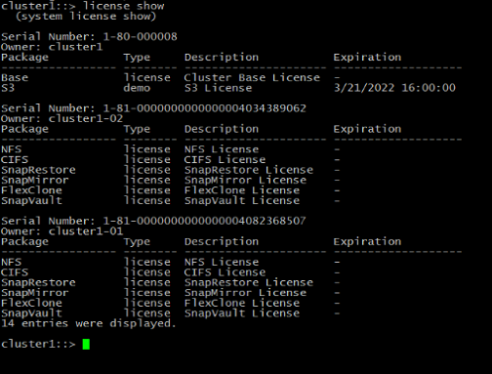

**Module 2: Cluster Setup**

**Exercise 2-1: Exploring ONTAP Management UIS**

**Task 6: Explore ONTAP System Manger**

**Page33_Step6-29**: The screenshot will vary so kindly refer the below image.

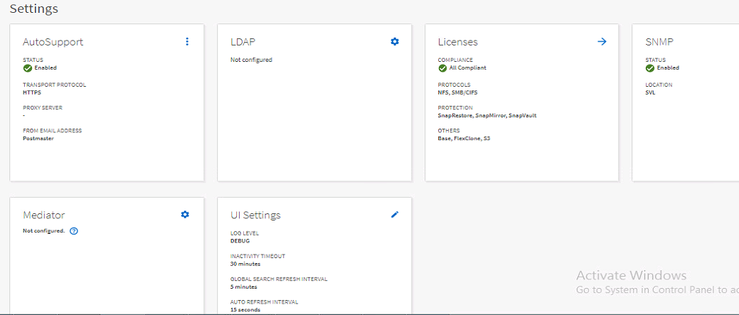

**Module 3: Cluster Management**

**Exercise 3-1: Managing ONTAP Cluster and Administrators**

**Task 2: Explore Licensing**

**Page38_Step2-1:** The screenshot will vary so kindly refer the below image.

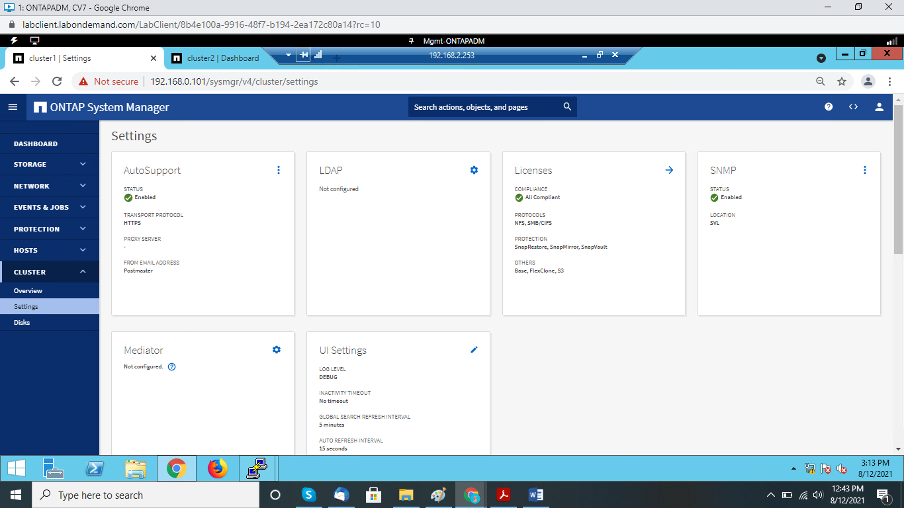

**Task 3: Configure Cluster Time and Assign an NTP Server**

**Page40_Step3-3:** The **Time Zone** will be **Asia/Singapore** therefore **DATE AND TIME** in the screenshotwill vary so kindly follow the below image.

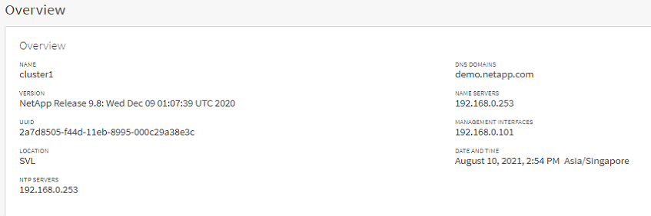

**Page40_Step3-4:** The **Time Zone** for the Windows and Linux will be pre-configured to **Asia/Singapore**.

**Module 5: Physical Storage Management**

**Exercise 1: Managing Physical Storage**

**Task 3: Create Aggregate**

**Page69_Step 3-2 & 3-3:** In this task **Storage Recommendation** Usable value will vary in the **Add Local Tier** window.

**Module 7: Data Access**

**Exercise 1: Configuring NAS Protocols in an SVM**

**Task 1: Configure an SVM to Host the NFS Protocol**

**Page92_Step1-5:** The screenshot will vary for Access Protocol window so follow the below image.

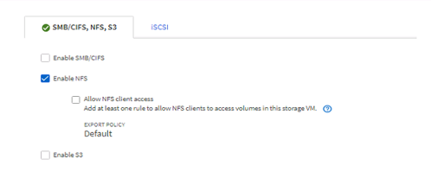

**Page93_Step1-8:** Use Gateway as **192.168.0.253** instead of **192.168.0.1** follow the below screenshot.

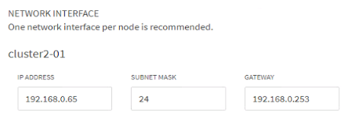

**Exercise 2: Configuring the SMB Protocol in an SVM**

**Task 1: Configure an SVM to Host the SMB Protocol**

**Page105_Step1-9:** Change the **Gateway IP address** as **192.168.0.253** instead of using **192.168.0.1**.

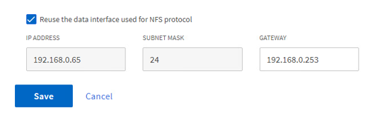

**Exercise 3: Configure an iSCSI in an SVM**

**Task 3: Use System Manager to Configure an SVM for iSCSI**

**Pg121_Step3-5:** The screenshot will vary for Access Protocol window so follow the below image.

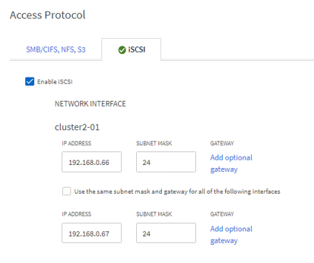

**Page123_Step3-9**: The Screenshot for the Storage VMs will vary so refer the below image.

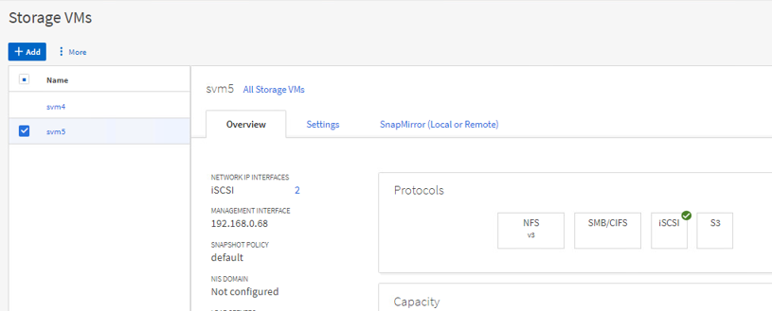

**Task 5: Access the iSCSI-Attached LUN from the Windows Host**

**Page134_Step5-3:** The **Initialization** of the disk will be done in **Step5-6**.

**Page134_step5-6:** Right click **Disk 1** then select **Initialize Disk** and click **OK**.

**Exercise 4: Configuring the S3 Protocol in an SVM**

**Task 1: Configure an S3 Protocol in a Storage VM**

**Page138_Step1-5:** The screenshot will vary for Access Protocol window so follow the below image.

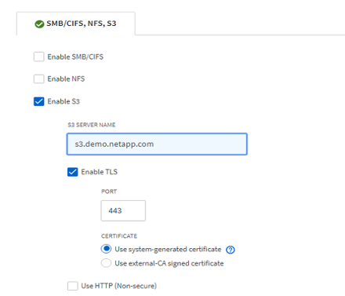

**Page139_Step1-7:** Use the **Gateway IP address** as **192.168.0.253** instead of **192.168.0.1**.

**Page142_Step1-19:** Save the File as **svm6cert.crt** in the **Downloads** folder.

**Exercise 5: Managing the NAS Storage VMs**

**Task 1: Migrate and Rehome a NAS Data LIF**

Note: Before starting to migrate and rehome the NAS data lif do the following in the cluster1 putty session.

cluster1: :> network interface modify -vserver svm2 –lif svm2_cifs_nfs_lif1 -auto-revert false



cluster1: :> network interface show –vserver svm2 –fields auto-revert

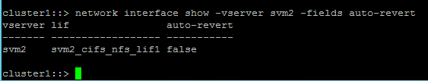

**Page162_Step1-17:** The **home node** for the LIF **svm2_cifs_nfs_lif1** will be **cluster1-02**.

**Module 9: Storage Efficiency**

**Exercise 1: Managing Storage Efficiency**

**Task 1: Explore Thin Provisioning**

**Page150_Step1-2 & Step1-3:** Give **yes**, if any warning prompts appears while creating aggregate.

**Bonus Module: Create a FlexGroup Volume**

**Task 1: Create a FlexGroup Volume**

**Page187_Step 1-7:** Give **yes** twice, if any warning prompts appears while enabling 64-bit identifiers and creating the FlexGroup Volume.

**Module 10: Cluster Maintenance**

**Task 2: Verify Cluster Health with Config Advisor**

**Page198_Step2-16:** After clicking **Shutdown** to exit the Config Advisor click **Confirm Shutdown**.

**Task 4: Change the Cluster Admin Password**

**Page199_Step4-6:** You can’t use the **Last 6 password** while resetting the password for **Cluster1** so use the new password for the **Cluster1.**